**DISCRIPTION ANS NAVIGATION THE PROJECT**

There are 8 pages in the project DBC (dragon boat club). User can find information about dragon boat sport, about club, the schedule of training, the price, the festivals (the competitions): dates, places, prices, choose and buy staff for padding and find contacts of club in social nets. Site was created in French language for french audience which can be interesting in dragon boat sport.

**Navigation site (and tags and attributes what were used):**

**P1_start.html (**has css file: formatP1.css; meta; links for other pages; background-image;mailto; links for location) represents club(contacts) and dragon boat and links for other pages:

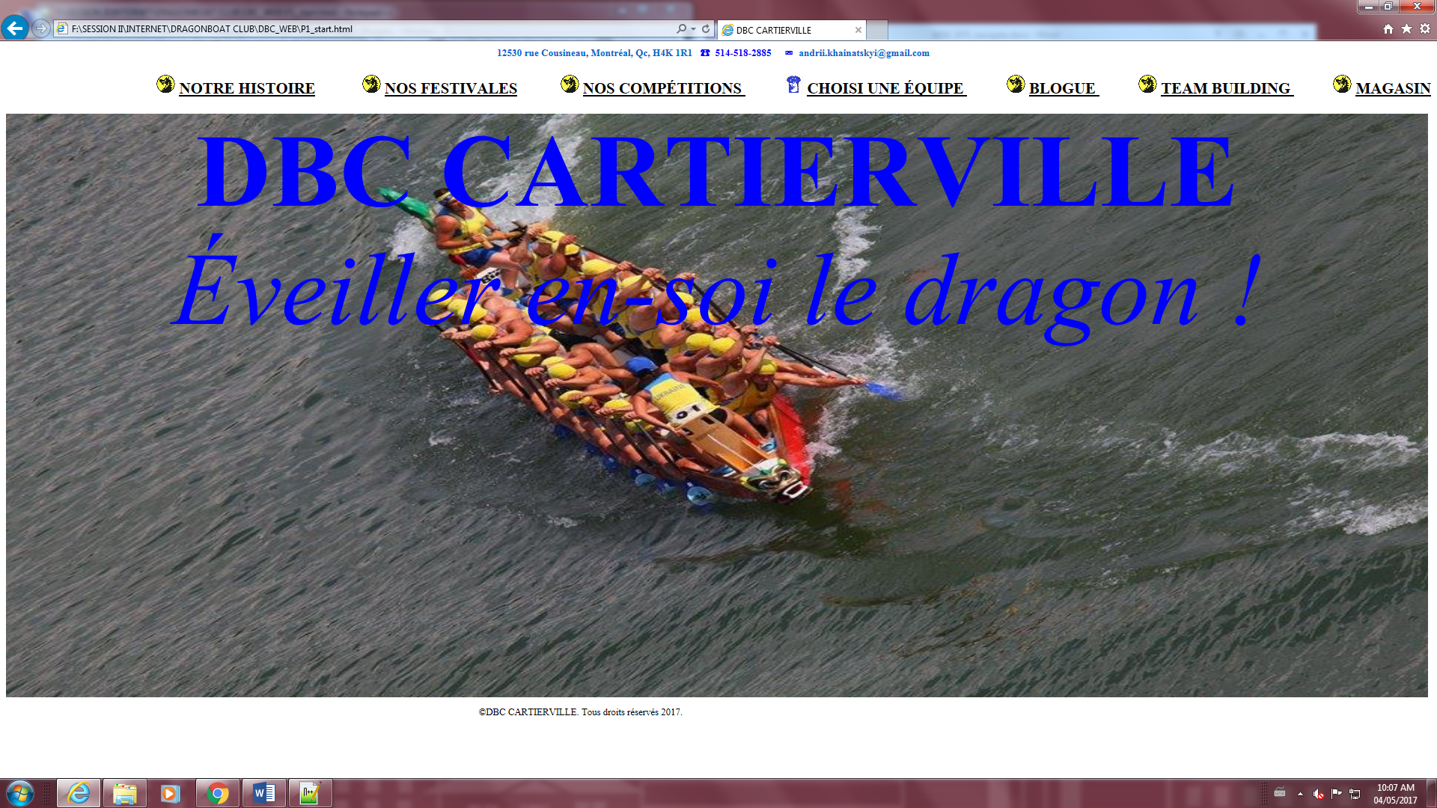

**P2_histoire.html (**has css file: formatP2.css; meta; links(cover) for other pages; image(float); list ul and li and list style image, table; title; logo – go to the first page). For user page explains what is dragon sport

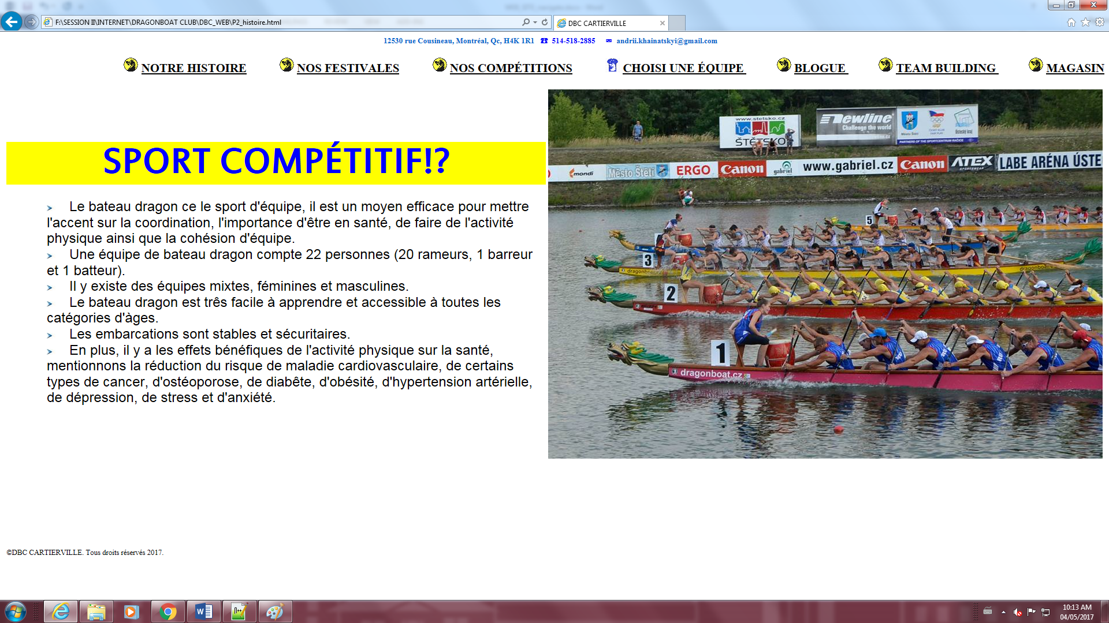

**P3_festivales.html html (**has css file: formatP3.css; meta; links(cover) for other pages; images; definition list dd and dl; links to all pages). For user page shows photos of festivals.

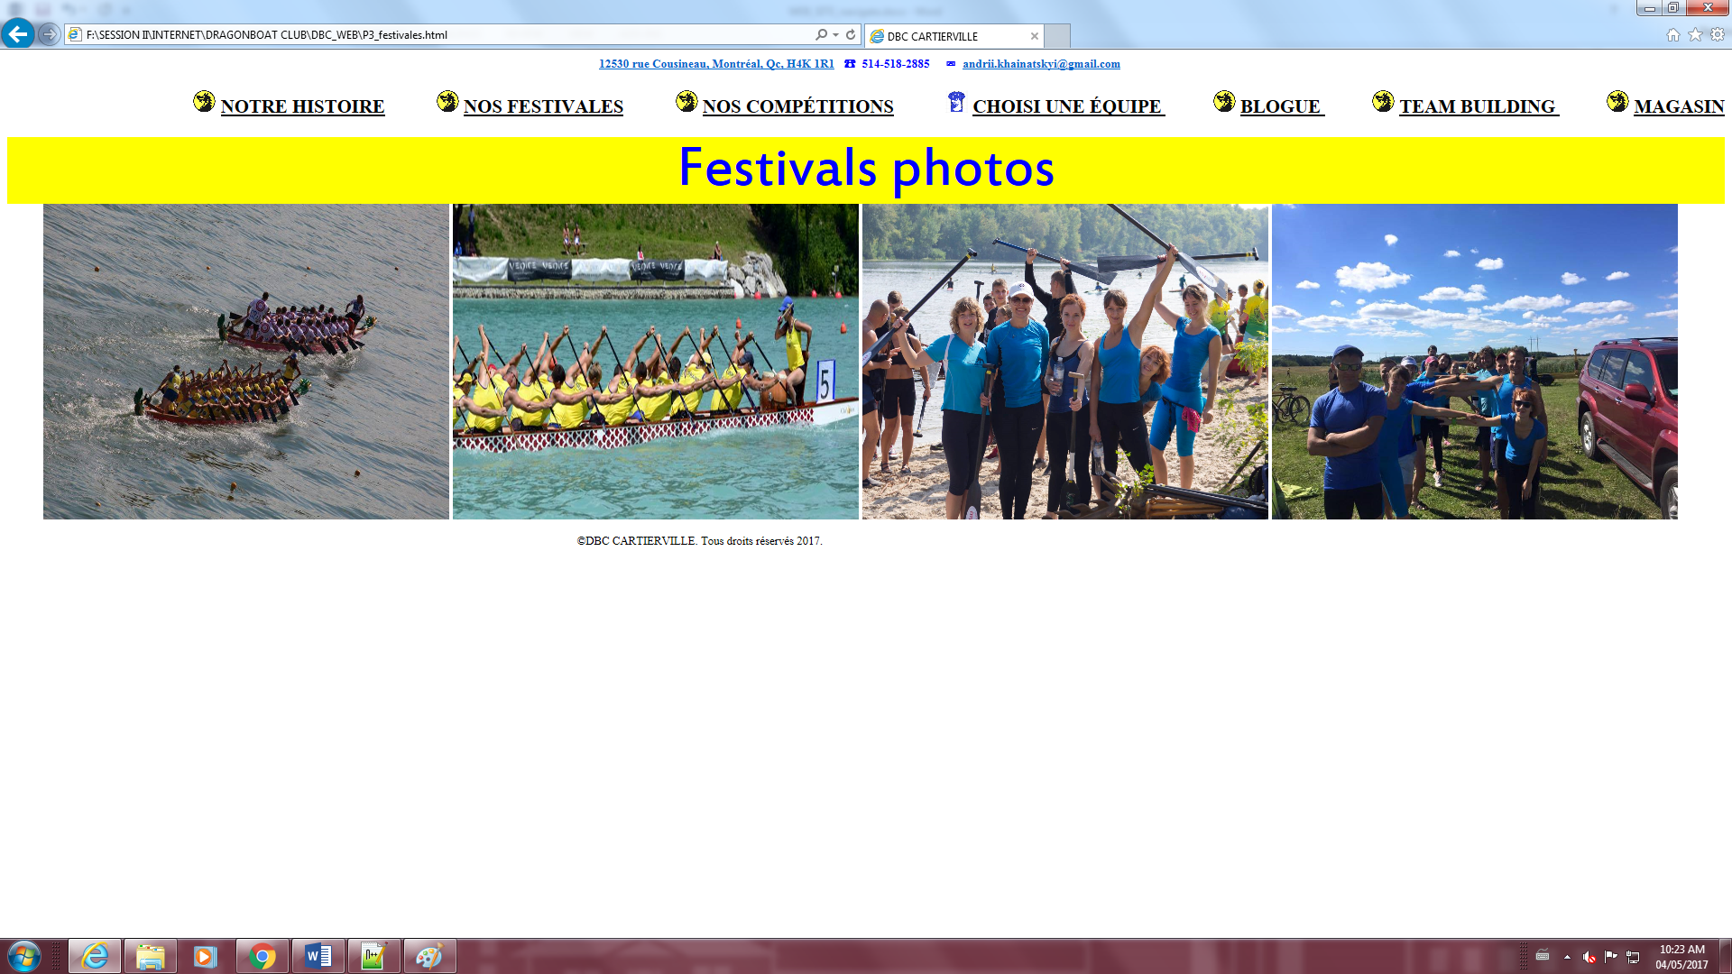

**P4_promotions.html (**has css file: formatP4.css; meta; links(cover) for other pages; images; table; inside table form inscription; inside css file attributes for table and forms, radio buttons; checkbox, select list; in html inline style). On this page user can fill out inscription form; look for festivals information (dates and place) and choose price.

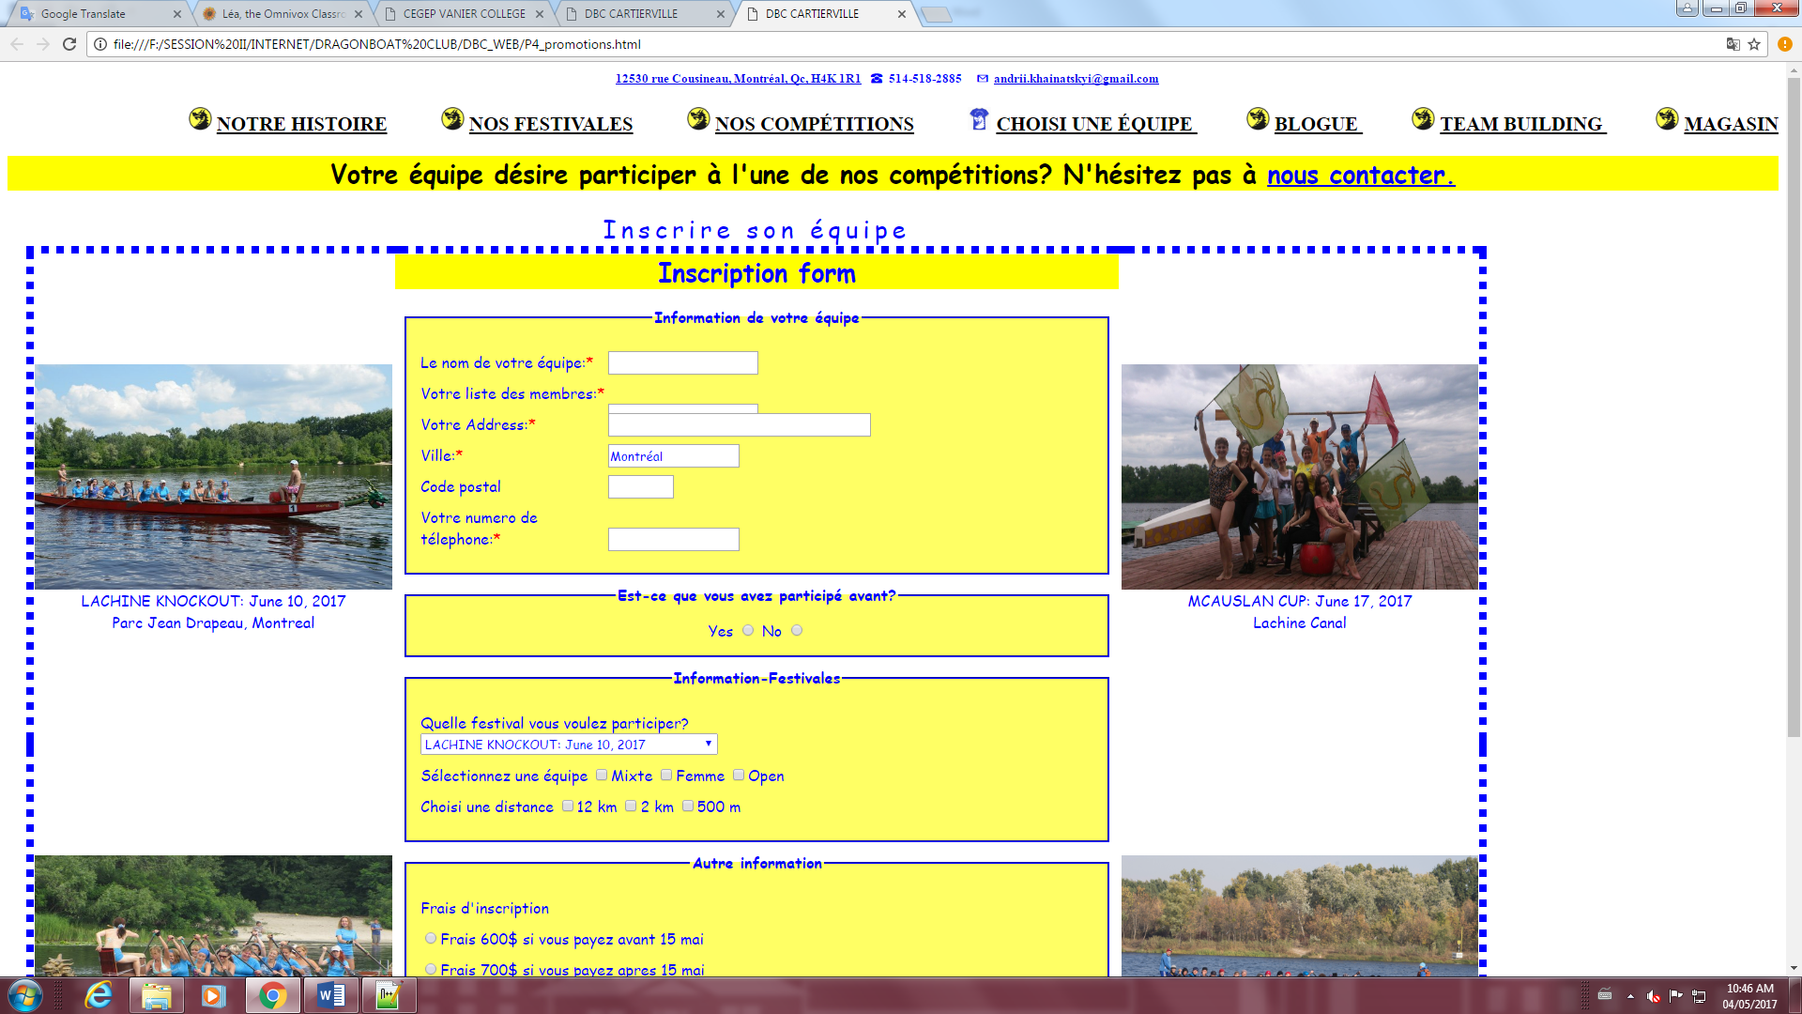

**P5_equipe.html(**has css file: formatP5.css; meta; links(cover) for other pages; images; table; background-image; inline style)

User can see all information about price for training, which group existed.

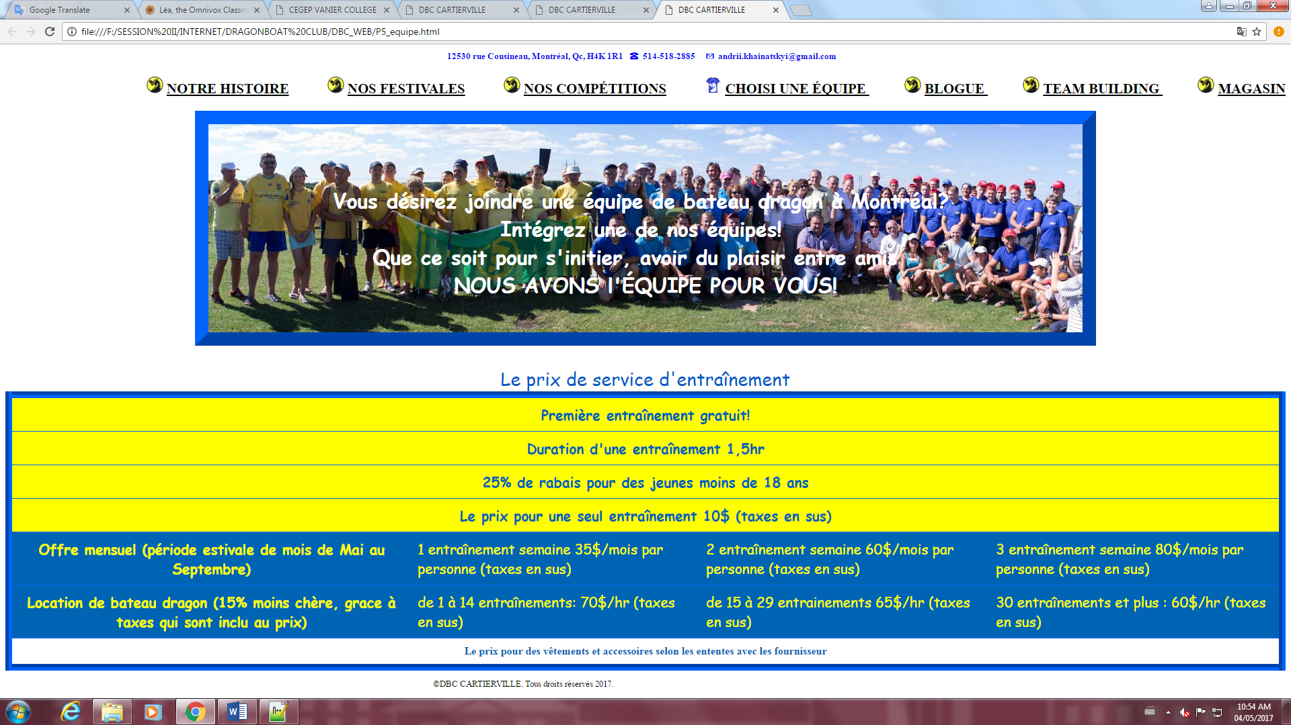

**P6_blogue.html** (has css file: formatP5.css; meta; links(cover) for other pages; images; embedded map; links). User can find location, contacts in social nets (facebook, Instagram, twitter, youtoube..)

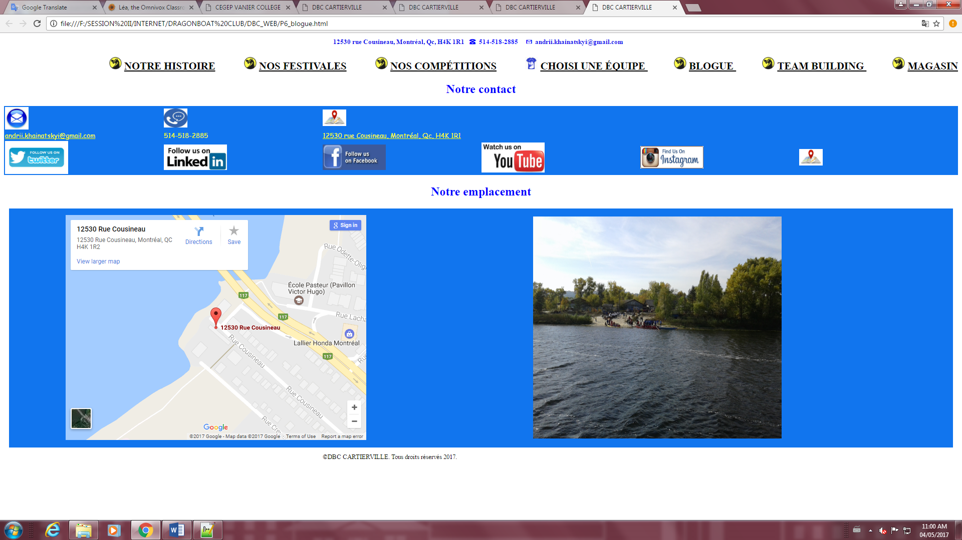

**P7_team.html** (use css file formatP5.css; has links; image made by using program GIMP; embedded style;background-image)

This page shows advantages/opportunity of dragon boat like sport team building.

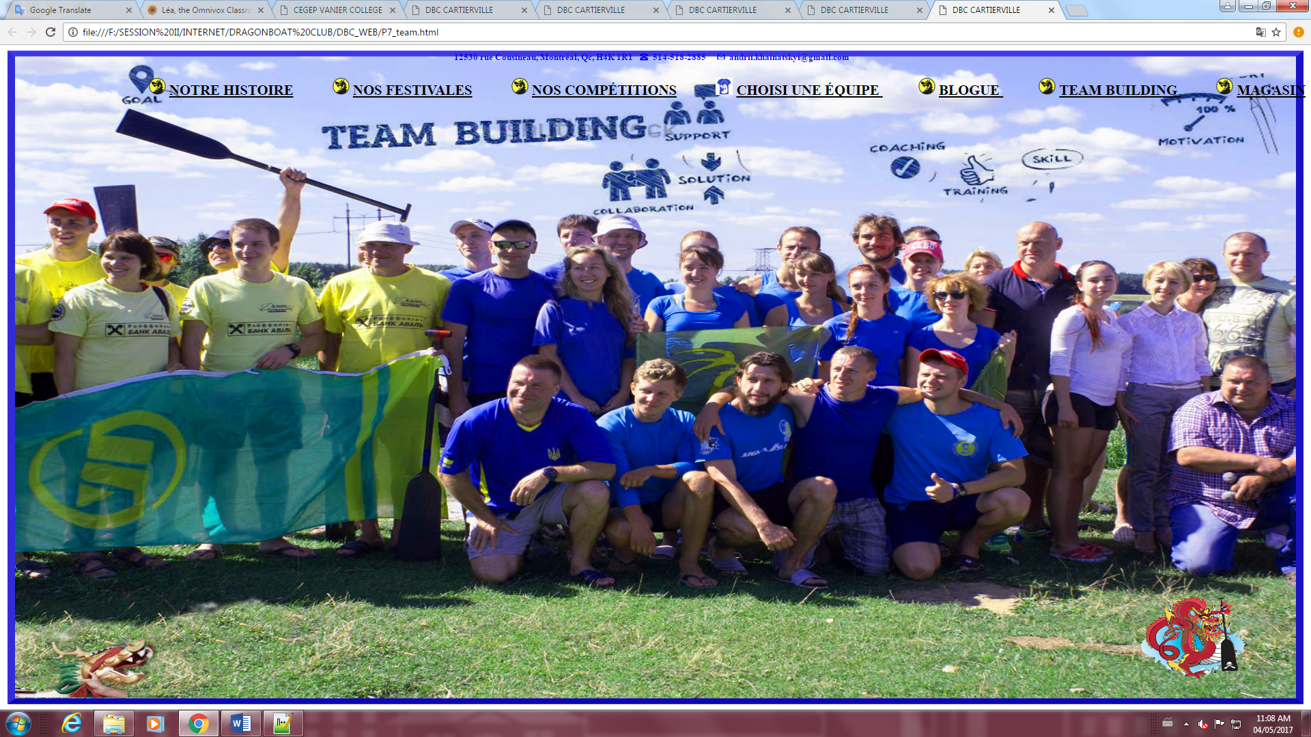

**P8_magasin.html** (use css file formatP5.css; has links; image; embedded style; definition list; links for section;links for make image more bigger; attributes for text).

User can read and choose staff for padding: paddle; accessories; boats. Can find the price and contacts.

